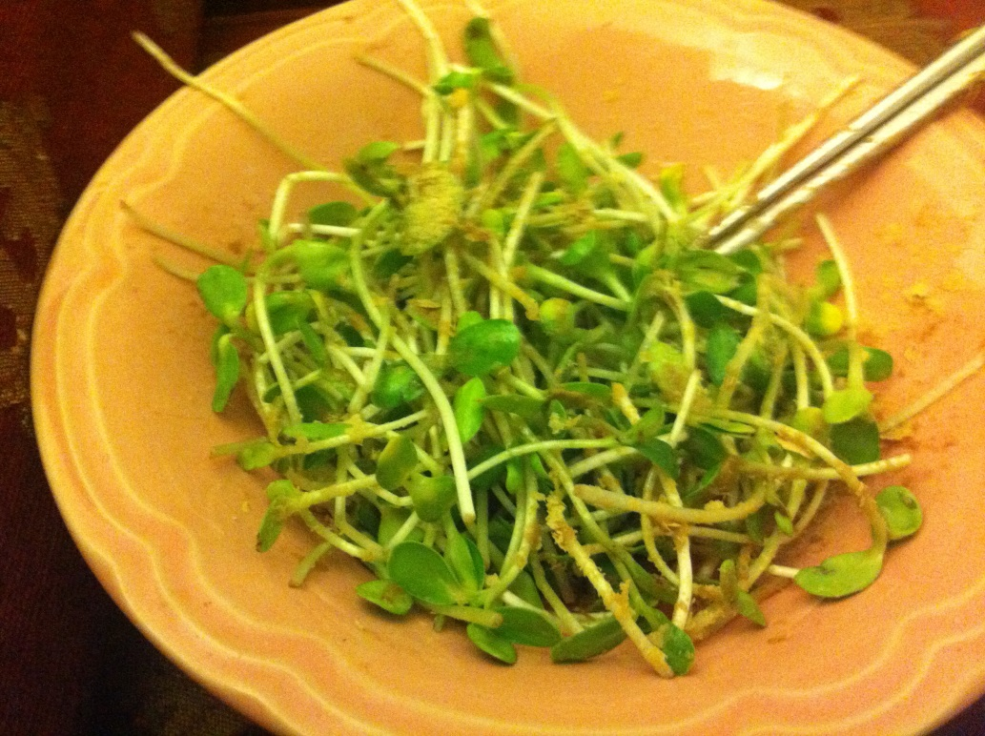
Sunflower Micro-Greens

- Sunflower Greens are packed with more protein than spinach, according to the International Sprout Growers Association.

- Sunflower Greens provide vitamin D, a substance that builds strong bones and muscles and is associated with controlling blood pressure, according to the Harvard School of Public Health. These sprouts are also a source of lecithin, a phospholipid compound that aids in the body's transport of fats.

- In a 2010 publication of "Acta Universitatis Sapientiae, Alimentaria," researcher M. Marton and coauthors reported a high content of linoleic acid in sunflower sprouts. This essential fatty acid is noted for its role in brain function, skin and hair growth and healthy bones, according to the University of Maryland Medical Center.

- In addition to fatty acids, sunflower sprouts are a great source of protein, says the International Sprout Growers Association, and are loaded with more than twice the protein content than Romaine and Iceberg lettuce.

- Sunflower greens are a nutritional powerhouse packed with vitamins A, B complex, D, and E; they also contain minerals including calcium, copper, iron, magnesium, potassium, phosphorus and zinc. In addition to these vitamins and minerals, sunflower greens are a rich source of lecithin which helps break down fatty acids into an easily digestible water soluble form, and chlorophyll which benefits many functions within the body, including building blood supply, revitalizing tissue, calming inflammation, activating enzymes, and deodorizing the body.

- Sunflower greens are a fantastic source of protein and can easily supply you with all the protein your body can use!

- Sunflower seed contains enough nutrients to start a whole new plant growing, one that can reach 6- to 12-foot (1.8 to 3.7 m) heights. In the germination process, all nutrients, including enzymes and trace minerals, multiply 300 to 1200%.

- Vitamins increase during sprouting when the seeds are producing a new life. Vitamin A increases to 50,000 IU, and Vitamin E offers 52.18 mg, while Vitamin D provides 92.0 IU for 3 1/2 ounces (100 grams). The Vitamin B family offers niacin at 4.50 mg, riboflavin at 0.25 mg, and thiamin at 2.29 mg. Sprouted sunflower seeds are also a rich source of iron, providing 6.77 mg for 31/2 ounces (100 grams) that can be a benefit to people with anemia.

